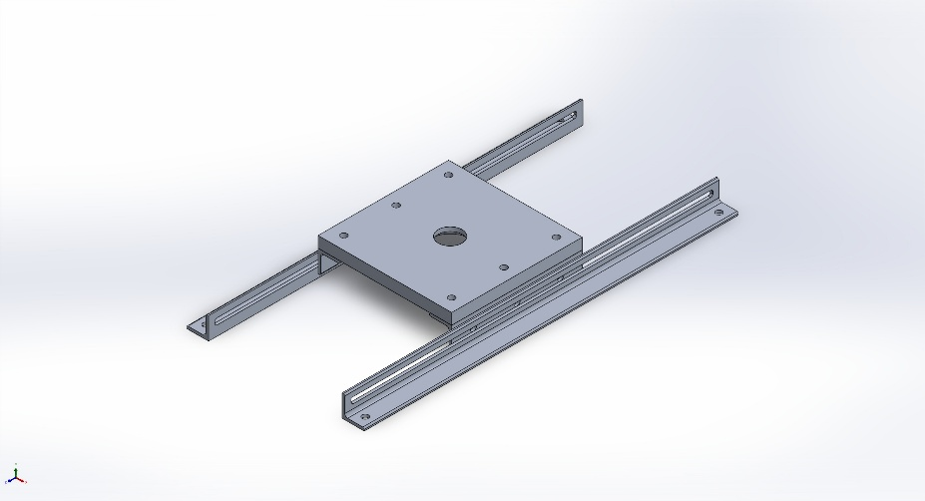
  Simulation of FullAssembly
  Date: Thursday, November 21, 2024
  Designer: Solidworks
  Study name: Static 1
  Analysis type: Static
  Table of Contents
  Description 1
  Assumptions 2
  Model Information 3
  Study Properties 5
  Units 6
  Material Properties 6
  Loads and Fixtures 7
  Connector Definitions 7
  Interaction Information 8
  Mesh information 9
  Sensor Details 10
  Resultant Forces 11
  Beams 11
  Study Results 12
  Conclusion 14

Description
No Data

Assumptions

Model Information

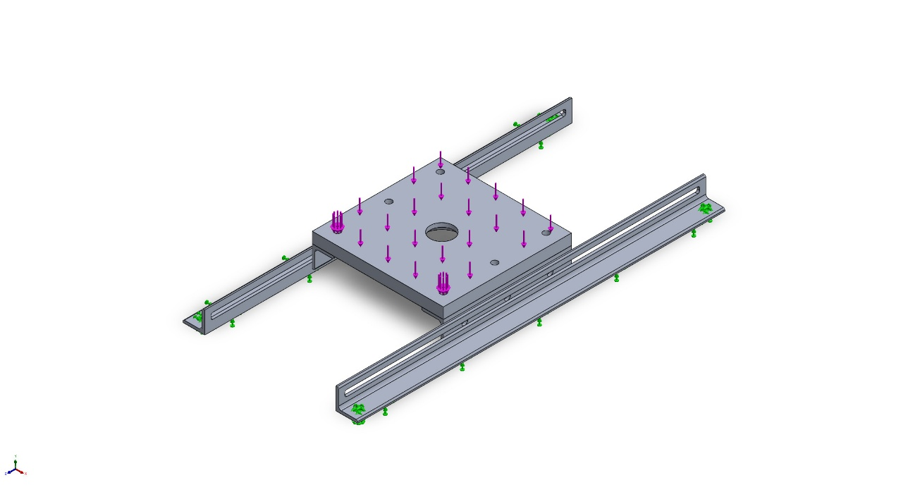
Model name: FullAssembly
Current Configuration: Default
Solid Bodies
Document Name and Reference | Treated As | Volumetric Properties | Document Path/Date Modified
Cut-Extrude2  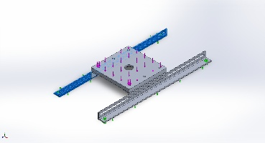 | Solid Body | Mass:0.0188078 kg  Volume:6.96586e-06 m^3  Density:2,700 kg/m^3  Weight:0.184317 N | C:\Users\super\OneDrive\Documents\!Pastore\KinovaArmTS\CAD\8982K546_Multipurpose 6061 Aluminum 90 Degree Angle Machined.SLDPRT  Nov 21 23:29:08 2024
Cut-Extrude2  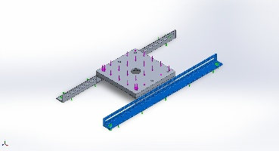 | Solid Body | Mass:0.0188078 kg  Volume:6.96586e-06 m^3  Density:2,700 kg/m^3  Weight:0.184317 N | C:\Users\super\OneDrive\Documents\!Pastore\KinovaArmTS\CAD\8982K546_Multipurpose 6061 Aluminum 90 Degree Angle Machined.SLDPRT  Nov 21 23:29:08 2024
Chamfer1  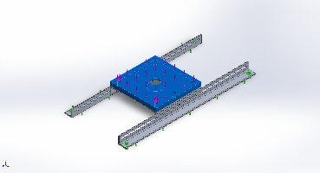 | Solid Body | Mass:0.0940492 kg  Volume:3.4833e-05 m^3  Density:2,700 kg/m^3  Weight:0.921682 N | C:\Users\super\OneDrive\Documents\!Pastore\KinovaArmTS\CAD\BaseMount.SLDPRT  Nov 21 23:29:07 2024
Cut-Extrude2  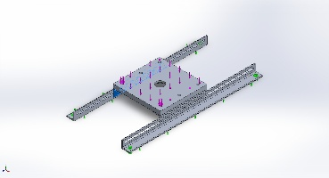 | Solid Body | Mass:0.00653621 kg  Volume:2.42082e-06 m^3  Density:2,700 kg/m^3  Weight:0.0640549 N | C:\Users\super\OneDrive\Documents\!Pastore\KinovaArmTS\CAD\MiddlePiece.SLDPRT  Nov 21 23:29:08 2024
Cut-Extrude2  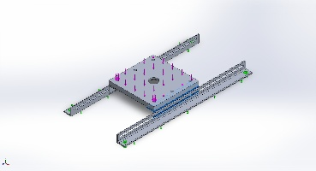 | Solid Body | Mass:0.00653621 kg  Volume:2.42082e-06 m^3  Density:2,700 kg/m^3  Weight:0.0640549 N | C:\Users\super\OneDrive\Documents\!Pastore\KinovaArmTS\CAD\MiddlePiece.SLDPRT  Nov 21 23:29:08 2024

Study Properties
Study name | Static 1
Analysis type | Static
Mesh type | Solid Mesh
Thermal Effect: | On
Thermal option | Include temperature loads
Zero strain temperature | 298 Kelvin
Include fluid pressure effects from SOLIDWORKS Flow Simulation | Off
Solver type | Automatic
Inplane Effect: | Off
Soft Spring: | Off
Inertial Relief: | Off
Incompatible bonding options | Automatic
Large displacement | Off
Compute free body forces | On
Friction | Off
Use Adaptive Method: | Off
Result folder | SOLIDWORKS document (C:\Users\super\OneDrive\Documents\!Pastore\KinovaArmTS\CAD)

Units
Unit system: | SI (MKS)
Length/Displacement | mm
Temperature | Kelvin
Angular velocity | Rad/sec
Pressure/Stress | N/m^2

Material Properties
Model Reference | Properties | Components
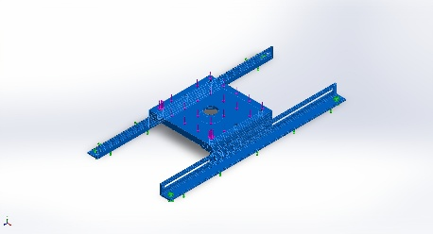 |  | SolidBody 1(Cut-Extrude2)(8982K546_Multipurpose 6061 Aluminum 90 Degree Angle Machined-1),  SolidBody 1(Cut-Extrude2)(8982K546_Multipurpose 6061 Aluminum 90 Degree Angle Machined-2),  SolidBody 1(Chamfer1)(BaseMount-1),  SolidBody 1(Cut-Extrude2)(MiddlePiece-1),  SolidBody 1(Cut-Extrude2)(MiddlePiece-2)
  Name: | 6061 Alloy
  Model type: | Linear Elastic Isotropic
  Default failure criterion: | Max von Mises Stress
  Yield strength: | 5.51485e+07 N/m^2
  Tensile strength: | 1.24084e+08 N/m^2
  Elastic modulus: | 6.9e+10 N/m^2
  Poisson's ratio: | 0.33
  Mass density: | 2,700 kg/m^3
  Shear modulus: | 2.6e+10 N/m^2
  Thermal expansion coefficient: | 2.4e-05 /Kelvin
Curve Data:N/A

Loads and Fixtures
Fixture name | Fixture Image | Fixture Details
Fixed-1 | 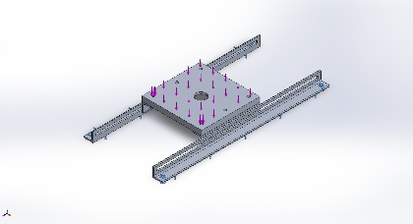
  Entities: | 6 face(s)
  Type: | Fixed Geometry
Resultant Forces
Components | X | Y | Z | Resultant
Reaction force(N) | -0.00027955 | 75.0002 | 0.000117823 | 75.0002
Reaction Moment(N.m) | 0 | 0 | 0 | 0

Load name | Load Image | Load Details
Force-1 | 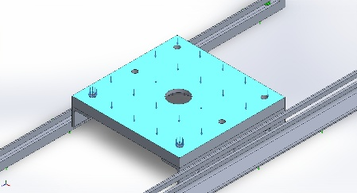
  Entities: | 1 face(s)
  Type: | Apply normal force
  Value: | 75 N

Connector Definitions
No Data

Interaction Information

Interaction | Interaction Image | Interaction Properties
Global Interaction | 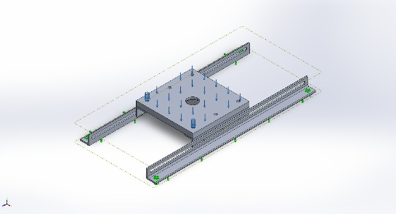
  Type: | Bonded
  Components: | 1 component(s)
  Options: | Independent mesh

Mesh information
Mesh type | Solid Mesh
Mesher Used: | Blended curvature-based mesh
Jacobian points for High quality mesh | 16 Points
Maximum element size | 4.02154 mm
Minimum element size | 0.303755 mm
Mesh Quality | High
Remesh failed parts independently | Off
Reuse mesh for identical parts in an assembly (Blended curvature-based mesher only) | Off

Mesh information - Details
Total Nodes | 139813
Total Elements | 74164
Maximum Aspect Ratio | 5.4497
% of elements with Aspect Ratio < 3 | 95.9
Percentage of elements with Aspect Ratio > 10 | 0
Percentage of distorted elements | 0
Time to complete mesh(hh;mm;ss): | 00:00:05
Computer name: | VITTOPC

Mesh Quality Plots
Name | Type | Min | Max
Quality1 | Mesh | - | -
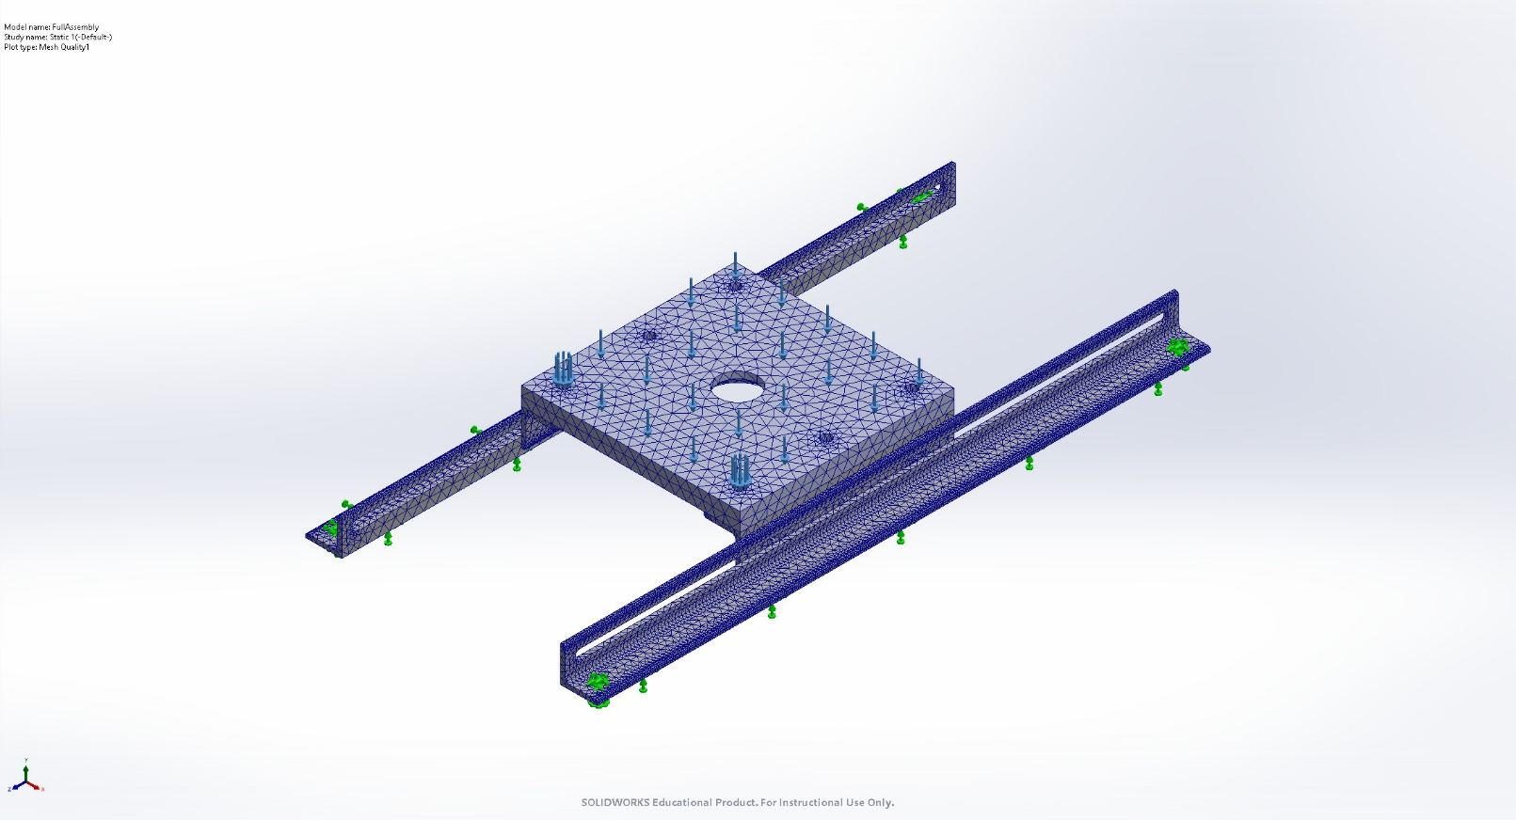
FullAssembly-Static 1-Quality-Quality1

Sensor Details
No Data

Resultant Forces

Reaction forces
Selection set | Units | Sum X | Sum Y | Sum Z | Resultant
Entire Model | N | -0.00027955 | 75.0002 | 0.000117823 | 75.0002

Reaction Moments
Selection set | Units | Sum X | Sum Y | Sum Z | Resultant
Entire Model | N.m | 0 | 0 | 0 | 0

Free body forces
Selection set | Units | Sum X | Sum Y | Sum Z | Resultant
Entire Model | N | 0.00522147 | -0.00627897 | -0.00193121 | 0.00839159

Free body moments
Selection set | Units | Sum X | Sum Y | Sum Z | Resultant
Entire Model | N.m | 0 | 0 | 0 | 1e-33

Beams
No Data

Study Results

Name | Type | Min | Max
Stress1 | VON: von Mises Stress | 4.779e-03N/m^2  Node: 24043 | 3.207e+06N/m^2  Node: 136118
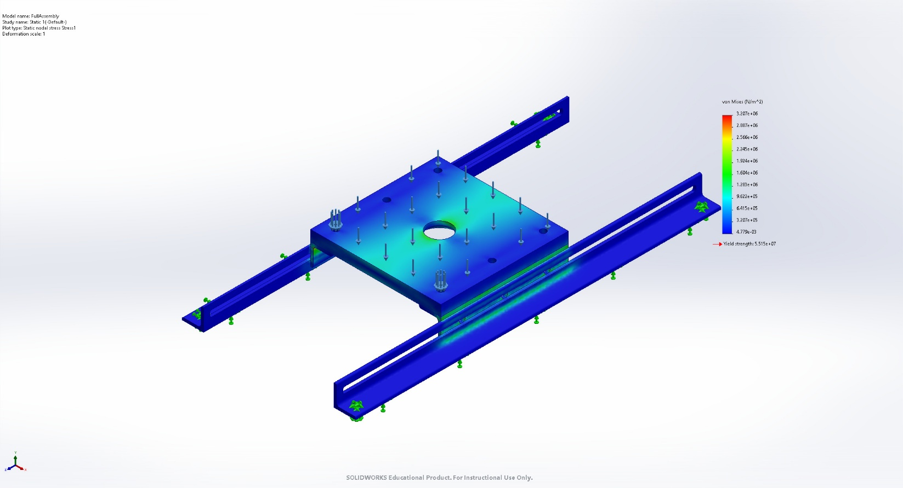
FullAssembly-Static 1-Stress-Stress1

Name | Type | Min | Max
Displacement1 | URES: Resultant Displacement | 0.000e+00mm  Node: 2 | 2.434e-03mm  Node: 90767
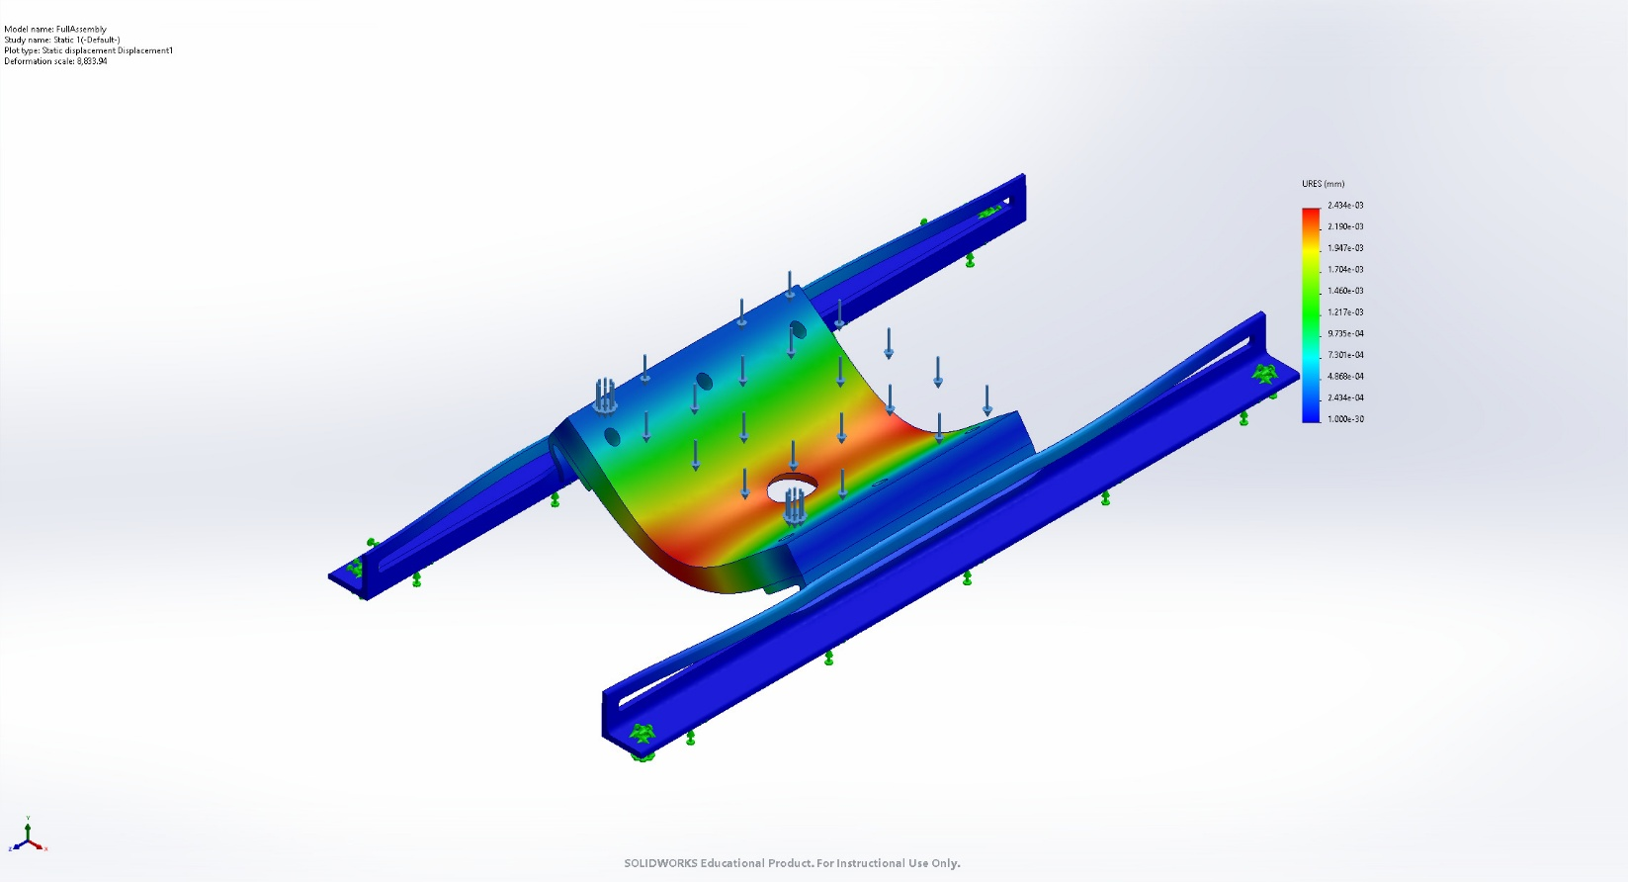
FullAssembly-Static 1-Displacement-Displacement1

Name | Type | Min | Max
Strain1 | ESTRN: Equivalent Strain | 6.291e-14  Element: 39793 | 3.226e-05  Element: 73532
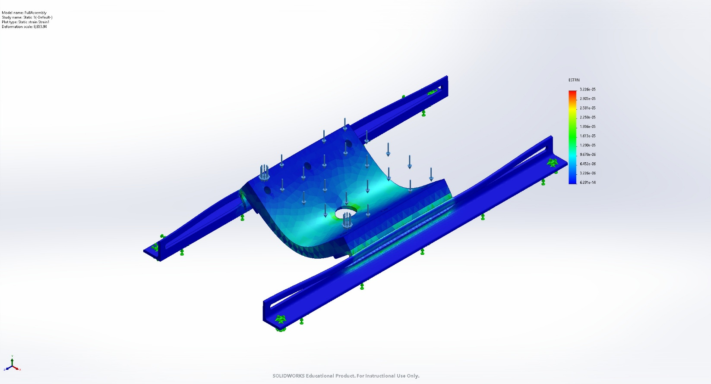
FullAssembly-Static 1-Strain-Strain1

Conclusion

